Fusion Motors

Operation Manual

Table of Contents

Installation of MongoDB 2

Installation of Fusion Motors 4

Using Fusion Motors 5

Logging In 5

First Login 6

Homepage 7

Searching 8

View Database 9

View Customers 10

Viewing Vehicles 11

Adding Customers/Vehicles 12

Add Customer 13

Viewing Added Customer 14

Add Vehicle 15

Importing Database 16

Exporting Database 17

# Installation of MongoDB

Fusion Motors database management system relies on Mongo DB to support its backend database. This means that in addition to the installation of Fusion Motors’ main application, mongo needs to be installed on the same machine. [[Install here](https://www.mongodb.com/try/download/community?tck=docs_server)]

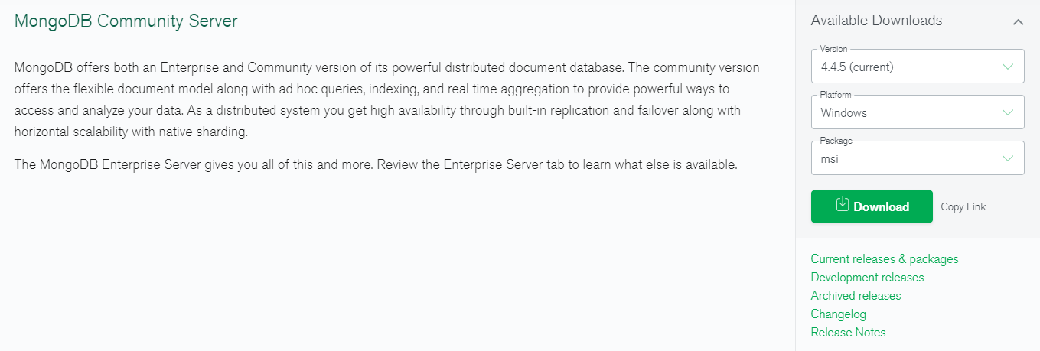

The application was developed and tested with MongoDB version 4.4; however future versions should be backwards compatible. Thus, for best results use this version.

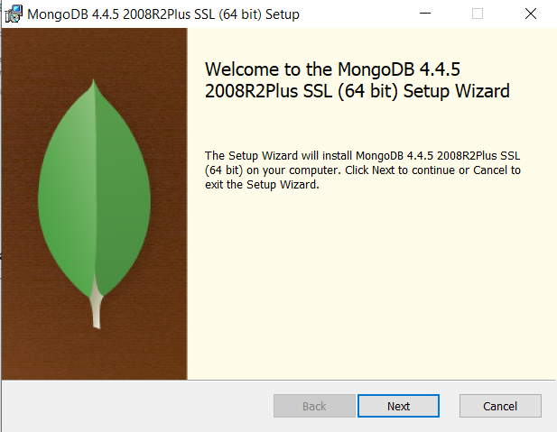

When the installer launches you will be met with the following window. Simply follow the wizard to install Mongo, take care to have the following settings:

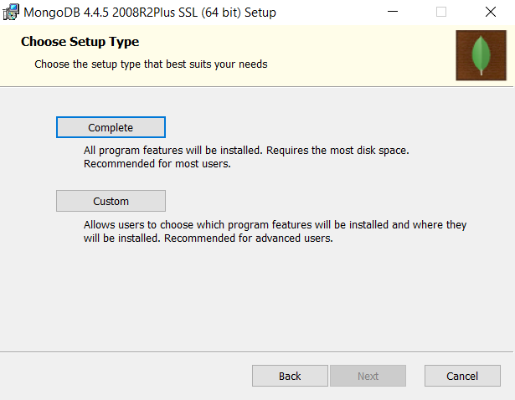

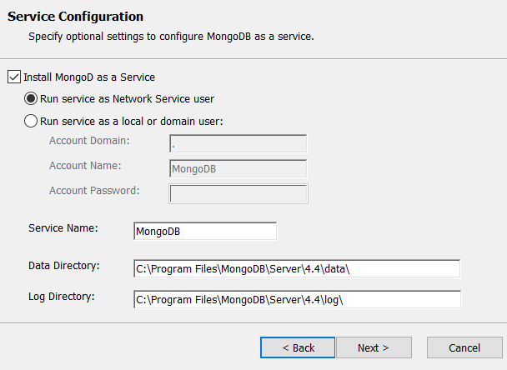

The Mongo directory can be changed; however, it is best to simply leave the installation settings as default.  
  
For a more in-depth installation guide, see the following video tutorial:   
**(Be sure to add mongo system environment variable)**  
<https://youtu.be/FwMwO8pXfq0>

# Installation of Fusion Motors

To install the Fusion Motors application, you can run the setup.msi application file and follow the wizard.

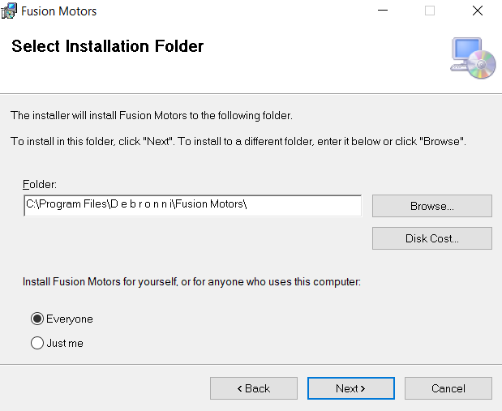

Once completed, you will be presented with a start menu shortcut, a desktop shortcut and the application will be installed to the location of your choosing.

# Using Fusion Motors

On launching the application, you will be prompted by user account control for administrative permissions for the application. This allows the application to run windows commands without constantly asking for input from you the user.

Logging In  
  
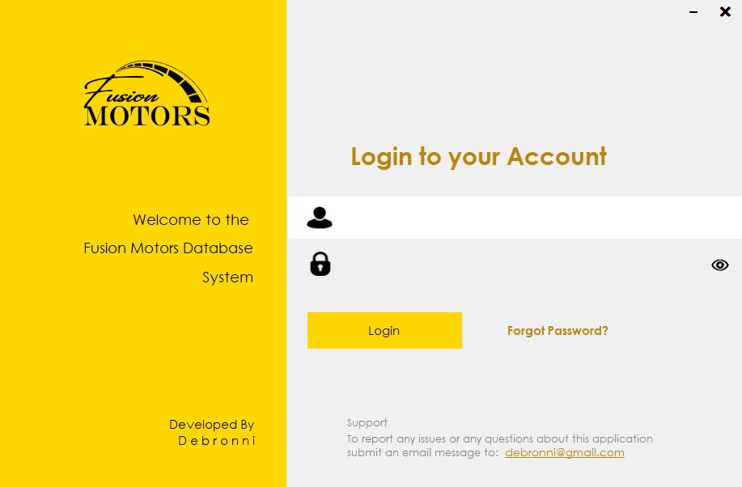

The login area will be the first screen you encounter upon launching the application. Here you will enter your username and password which can be found within the   
“Fusion Motors.dll.config”.  
  
**Username**: owner, - ( default fill is admin )  
**Password**: application - ( default fill is admin but hashed )  
(stored in a hashed format, unreadable unless run through a brisk hashing algorithm)  
  
The password once stored in a hashed format must be remembered by the user and copying the hashed password will not allow entry into the system.

## First Login

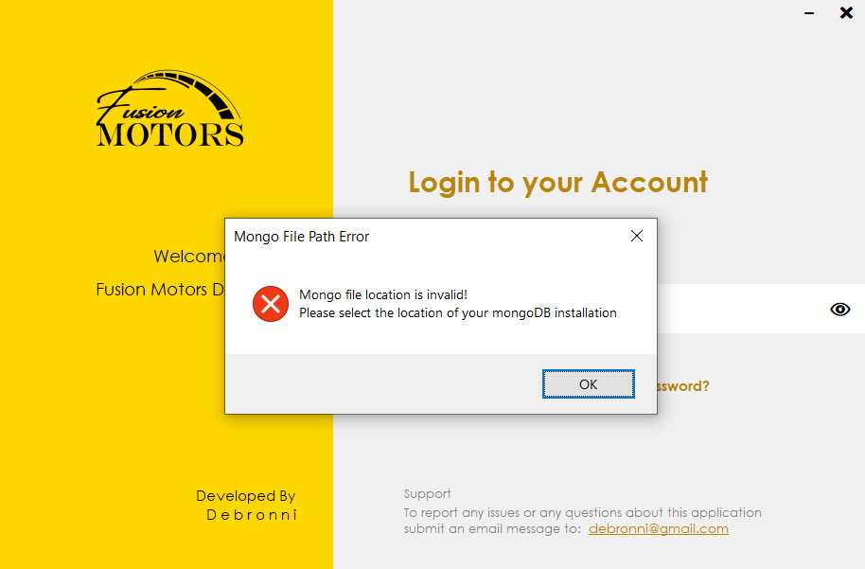

Upon first starting the application or removing the mongo Path setting within the   
“Fusion Motors.dll.config”. You will be met with this error which will prompt you to select and find the bin folder of your mongo DB installation. This path is pre-set to   
“C:\Program Files\MongoDB\Server\4.4\bin”.  
  
If your mongo is not connecting, simply remove this line   
  
in “Fusion Motors.dll.config” and relaunch the application. You will be prompted to select the folder from a folder dialog.

## Homepage

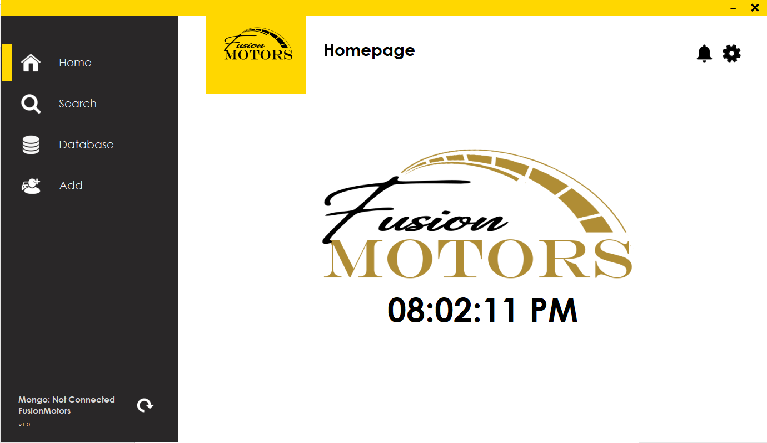

Upon logging in you will be met with the following homepage screen. Note that the application seeks to connect to the mongo database at this point and thus any loading of customers, vehicles etc will appear blank until the database status (bottom left) reports the application as connected to the database.

Should you lose connection, the application will give a 32 second window for a late response before it reports the database as disconnected. You can simply click the refresh arrow to renew this connection should anything go wrong.

In the top right you will see a notification icon and gear icon which represent a list of customers which you need to call back and the settings page, where you can import and export the database, respectfully.

The notification bell will be updated on visitation of the homepage after any updates to the database.

## Searching

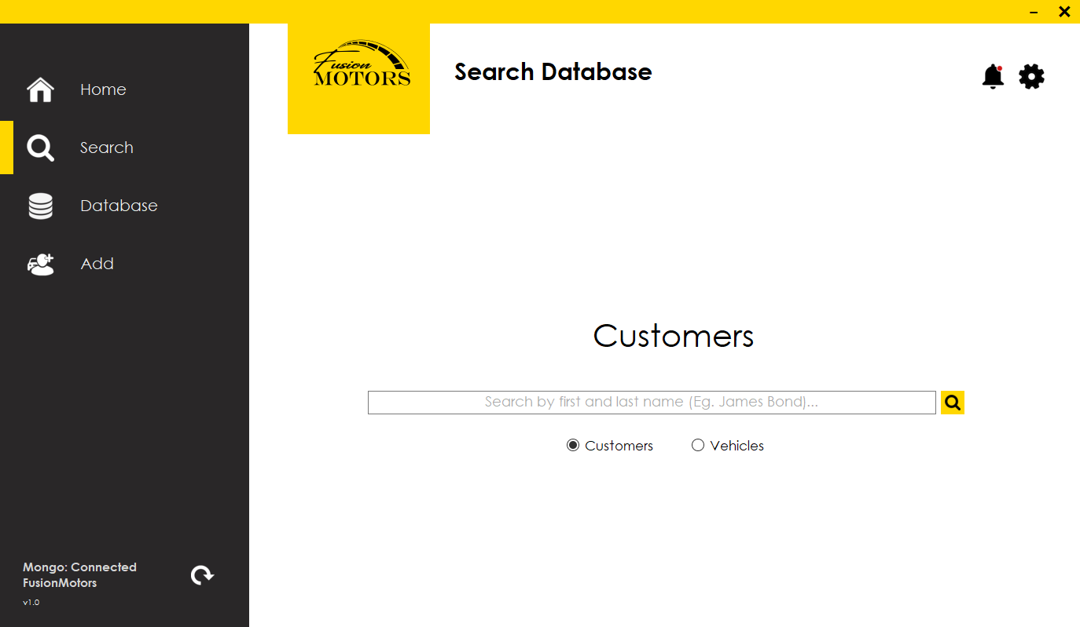

In the search page you can search customers by partial queries (“te” returns all customers whose first name begins with “te”) and search vehicles by their Engine numbers.

**Legal Customer Searches:**

***The search bar is NOT case sensitive***  
“ “ – A space before hitting enter or search will return a list of all customers in the database.

“ch” – Returns all customers whose first names begin with “Ch”.

“ch cod” – Returns all customers with first names beginning “Ch” and last names beginning with “Cod”.

“Christopher Codrington” – Returns all customers with the name Christopher Codrington.

The vehicles search is much stricter, and thus knowledge of the vehicle’s engine number must exist.   
There are various ways to access the database which will be discussed later.

## View Database

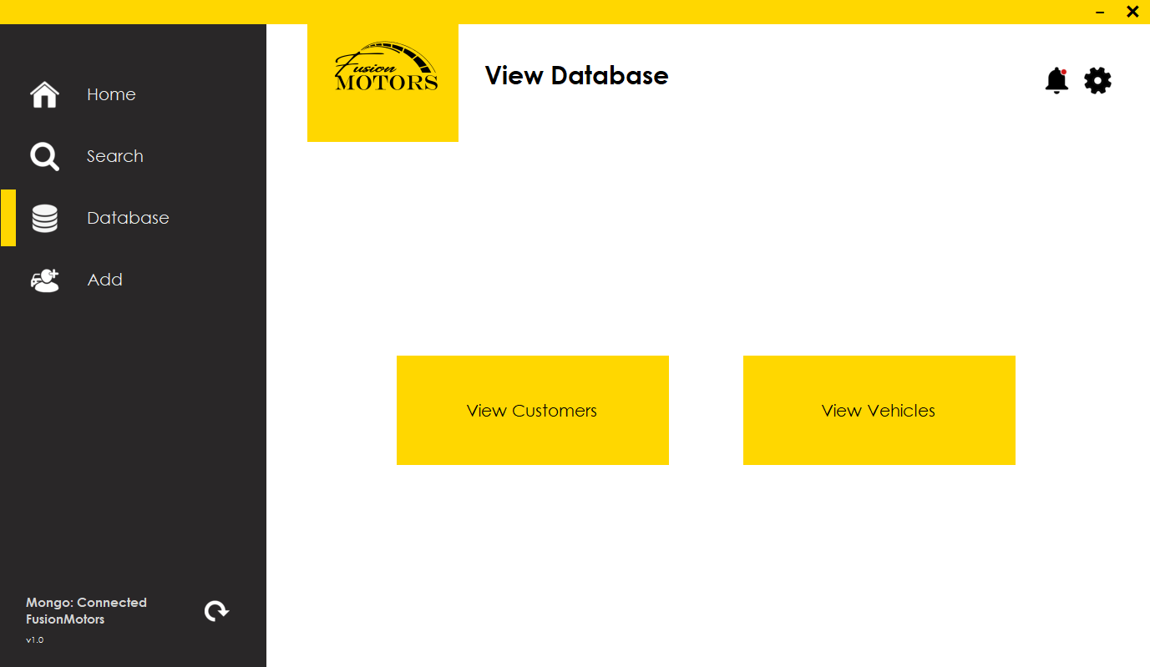

This page allows access to the full database of customers or vehicles in the system.

### View Customers

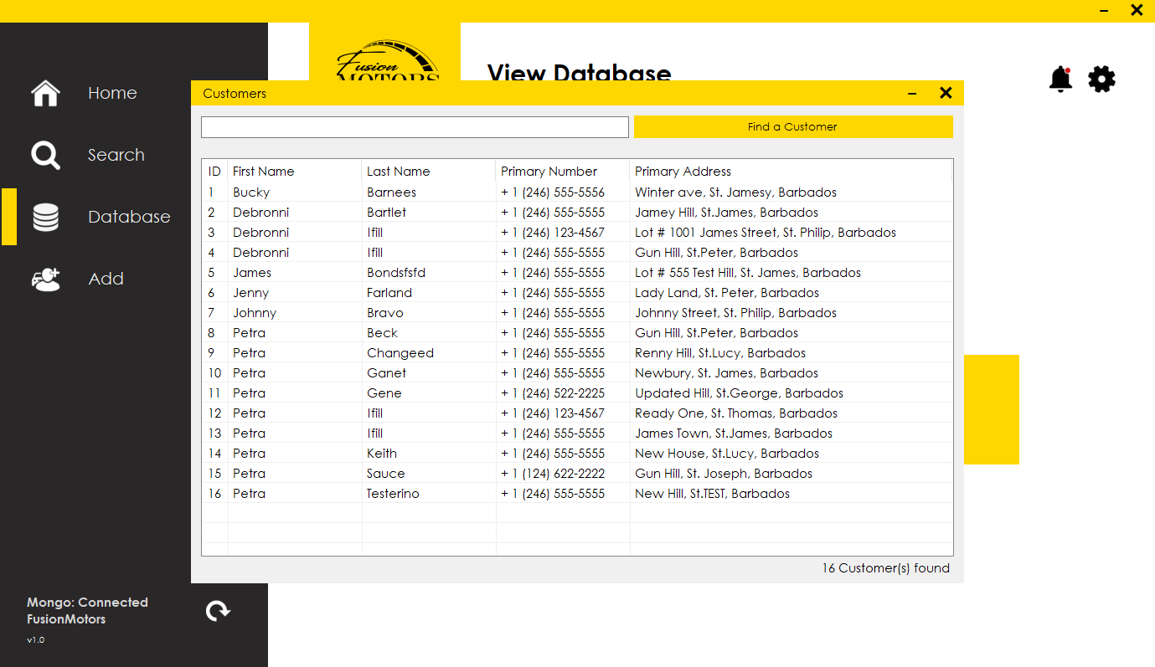

For the view customer pop out database view, the same search rules apply; however, should you wish to view the full database instead of filtered results, you can simply clear the textbox and hit the find a customer button to continue viewing all customers.

### Viewing Vehicles

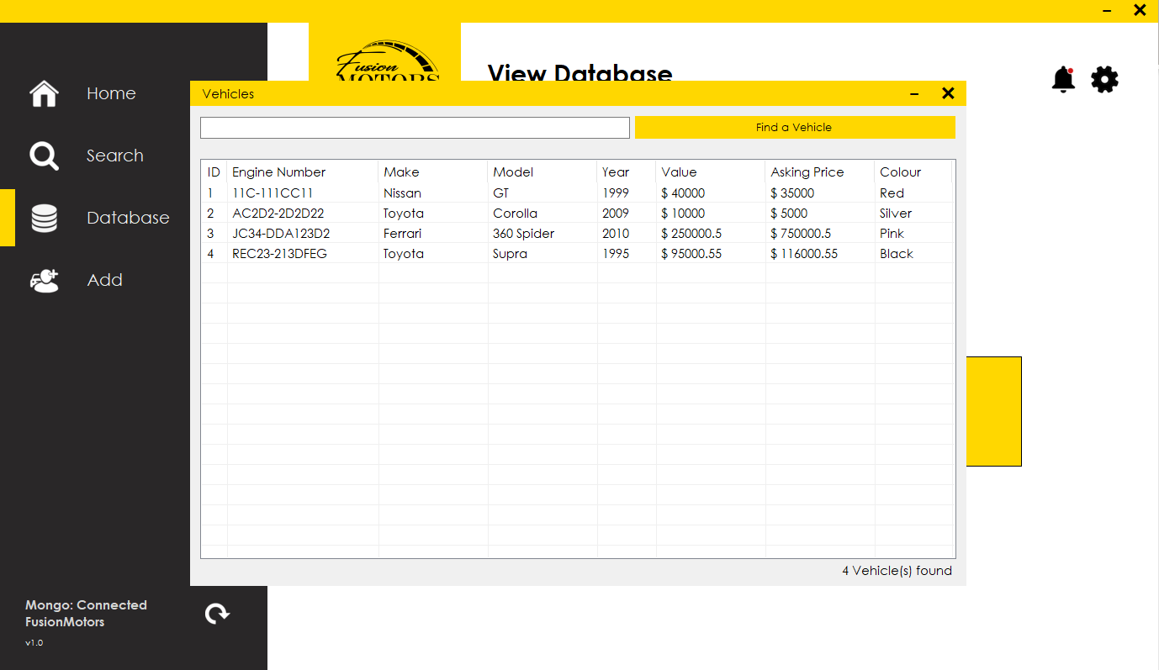

For the view vehicles pop out database view, the same search rules apply; however, should you wish to view the full database instead of filtered results, you can simply clear the textbox and hit the find a vehicle button to continue viewing all vehicles.

## Adding Customers/Vehicles

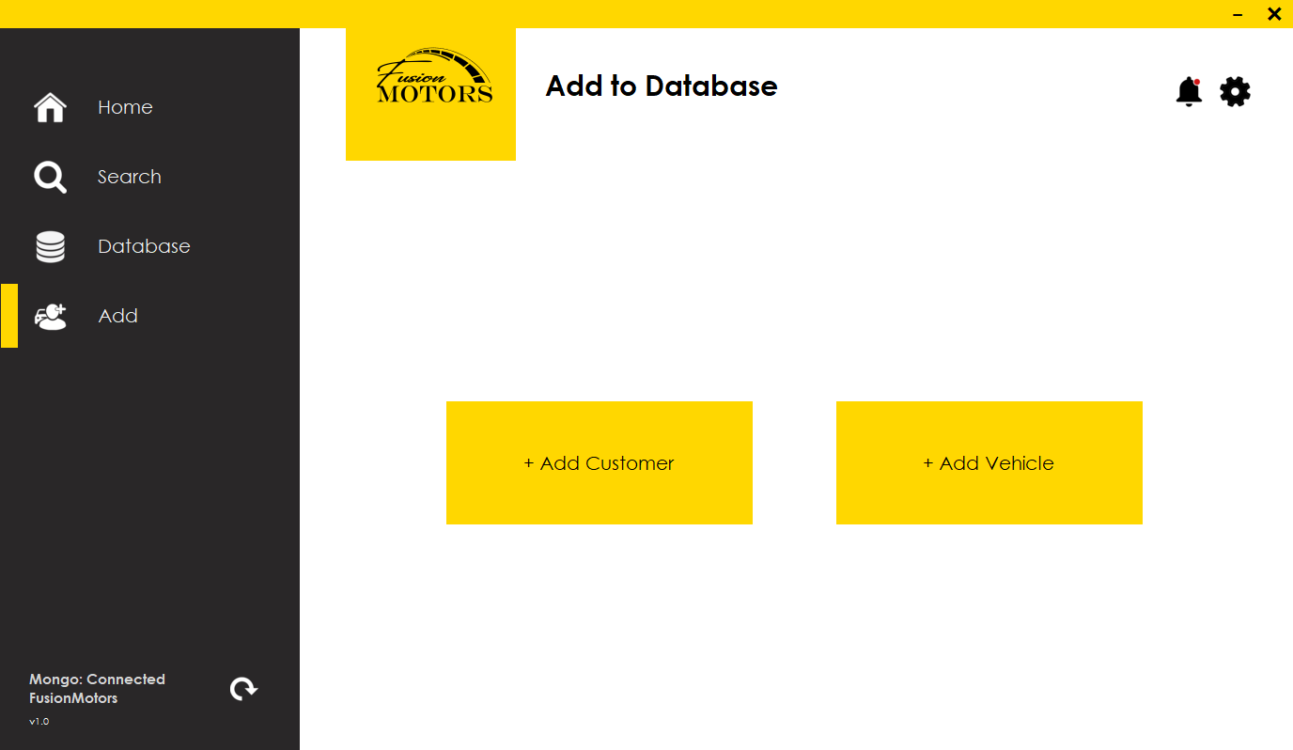

The add customer page allows access to the add customer page as well as add vehicle page.

### Add Customer

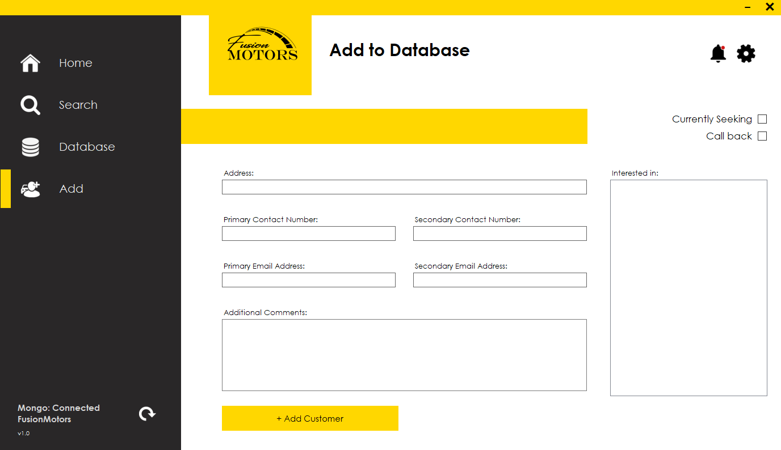

After you have added a customer, you will be allowed to add and remove interested vehicles for the customer.

Be mindful of the required fields   
Name, Address, primary contact number, and primary email address  
  
You cannot submit a customer unless the information in these fields are correct.

* Name must be in the format [Firstname Lastname] with one space between the names and capitalized First and Last names.  
  An address must be separated by 3 commas, [Street address, Parish, Country]
* Contact number must be 7 digits, 10 digits or the full 11 digits. (5551234, 2465551234, or 12465551234)
* An email address must be (email@domain)

### Viewing Added Customer

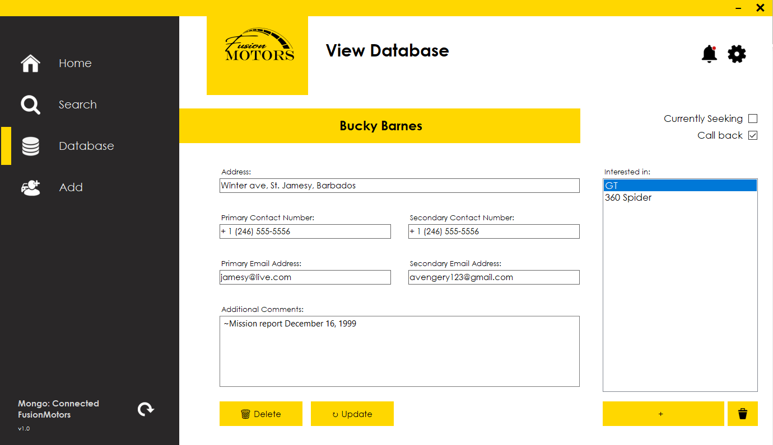

The list of added vehicle interest on the right can be double clicked to view the vehicle, however, be sure to save your changes to a customer before proceeding to do so.

### Add Vehicle

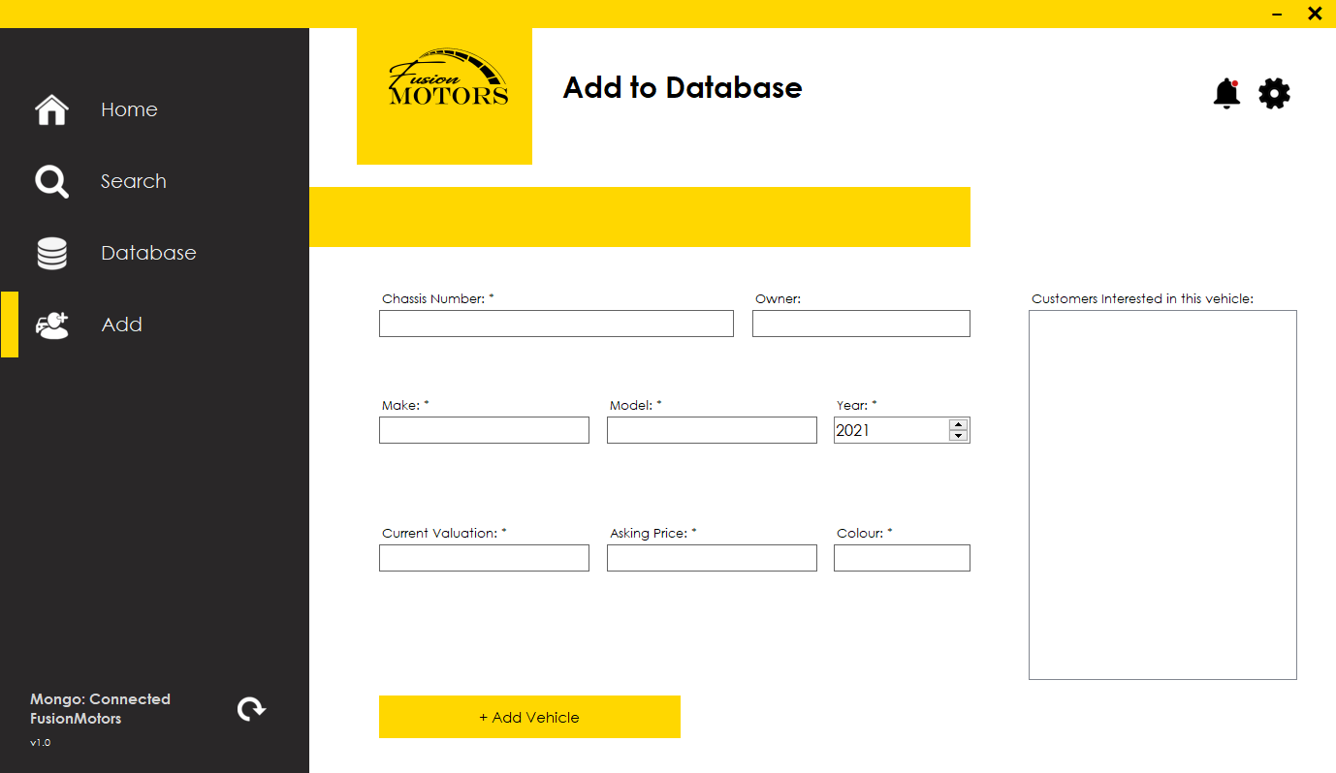

Be mindful of the required fields:  
Engine Number, Chassis Number, Model, Make, Year, Current valuation and asking price  
  
A Vehicle cannot be added unless all the fields are correctly filled out.  
  
When a customer adds or removes an interest in a particular vehicle, it is reflected in the list box on the right.   
  
Customers can be double clicked to be viewed in detail.

## Importing Database

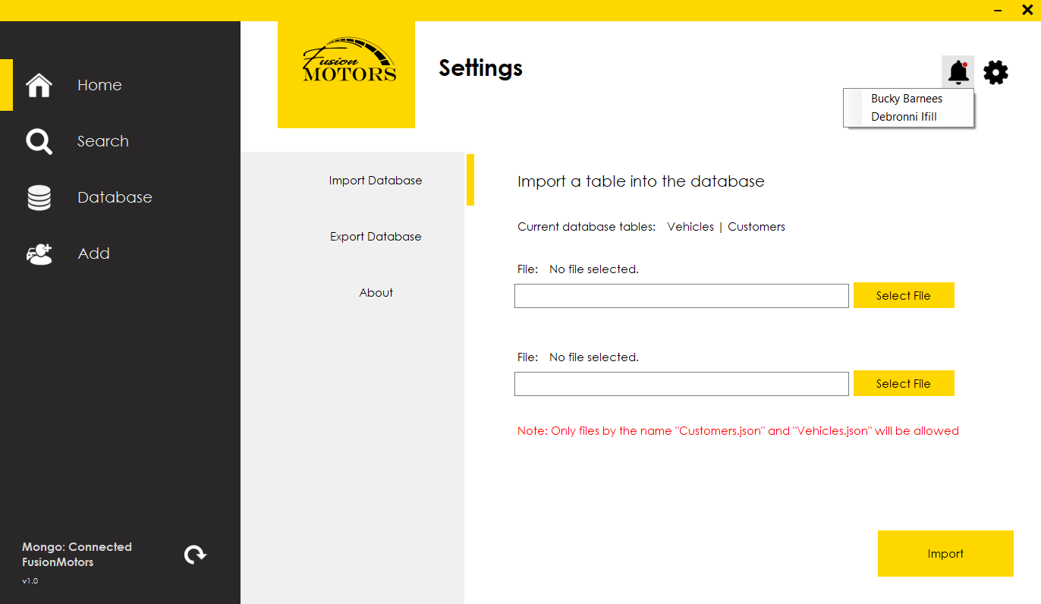

In this page, you can choose to import one table or two tables at once.   
  
The expected tables are “Customers.json” and “Vehicles.json” which match the intended database tables. When imported, changes to existing customers/vehicles will be updated to the imported file’s values and new customers/vehicles will be added should they not exist already.

## Exporting Database

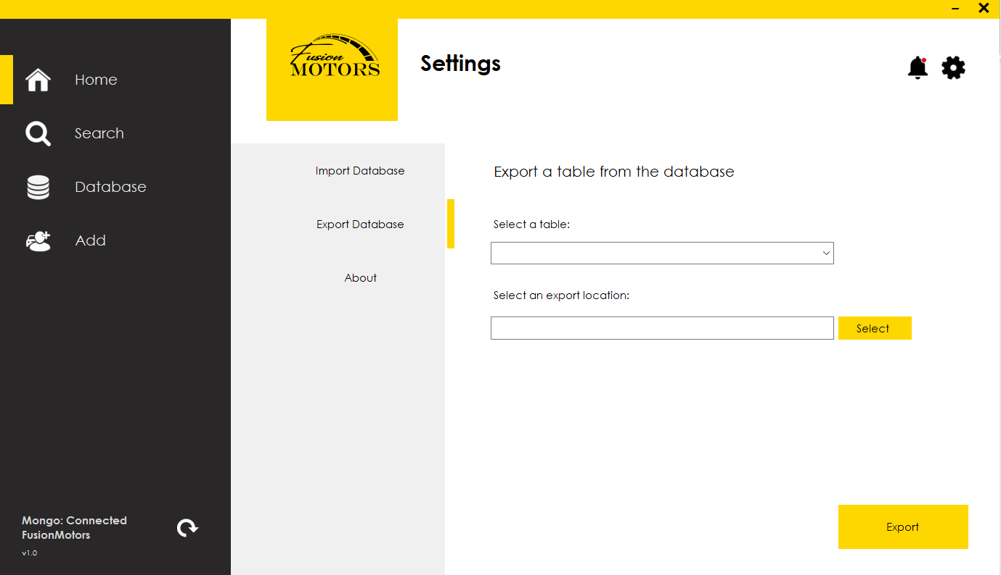

The application will export the current database to the intended folder and override any existing similar file there. **Be sure to export regularly in the case of mishap.**

**NB:**

**Should you encounter any errors be sure to raise a GitHub issue!**